11.01.2021
L.I: To use addition methods.

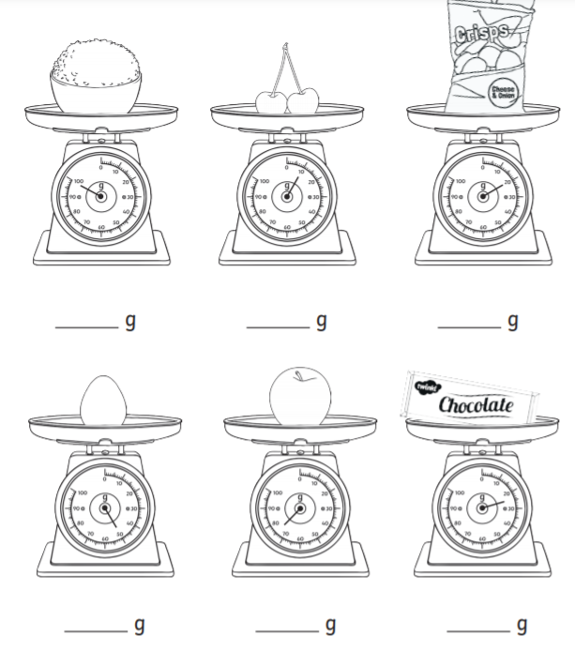
Starter: Can you find the weight of each object in grams?
Expanded column method

Below is a reminder on how to do the expanded column method.
Remember to follow these 4 basic steps to help you solve addition!
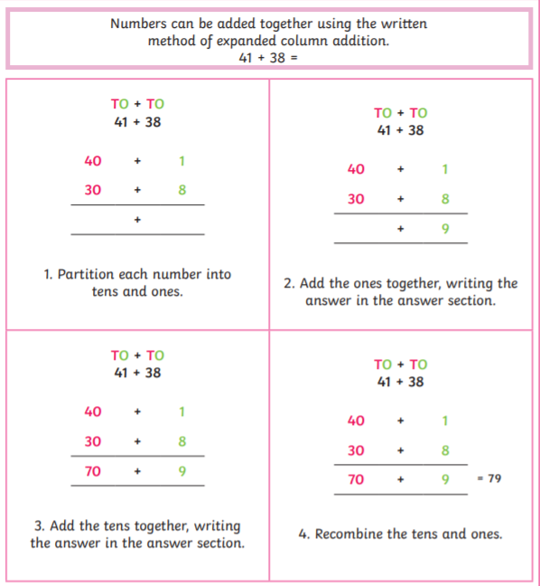

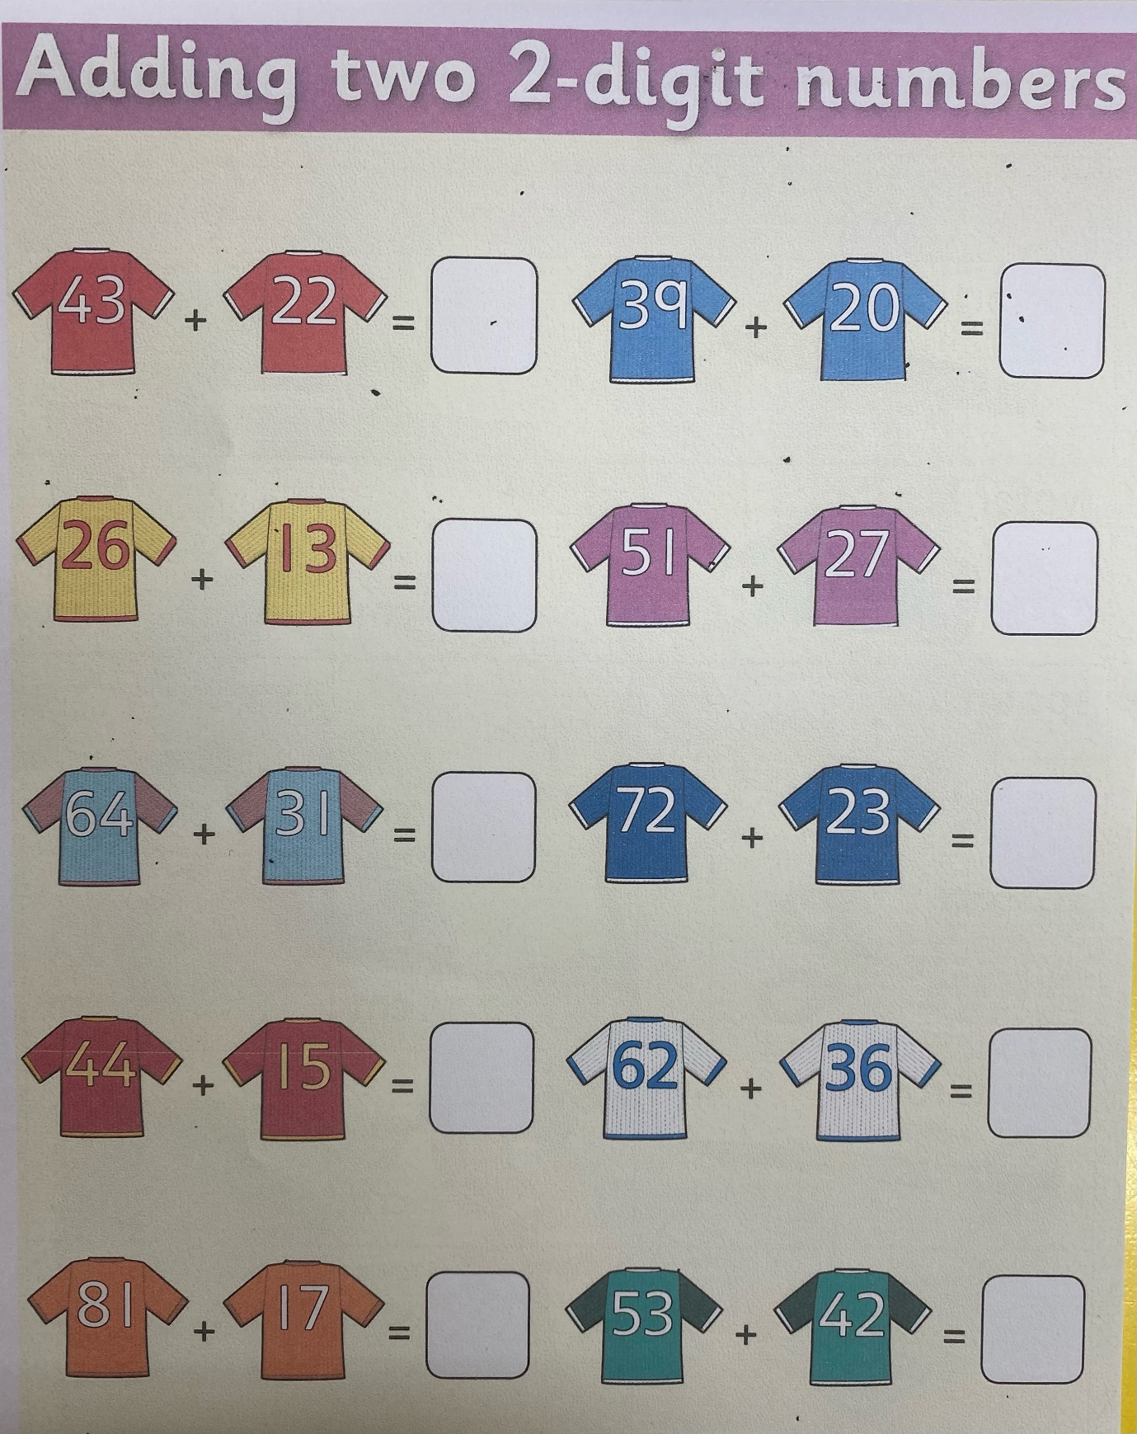
Activity: Adding two-digit numbers.

