11.01.2021
L.I: Add two 3-digit numbers using written column addition.

Starter: Solve these additions.
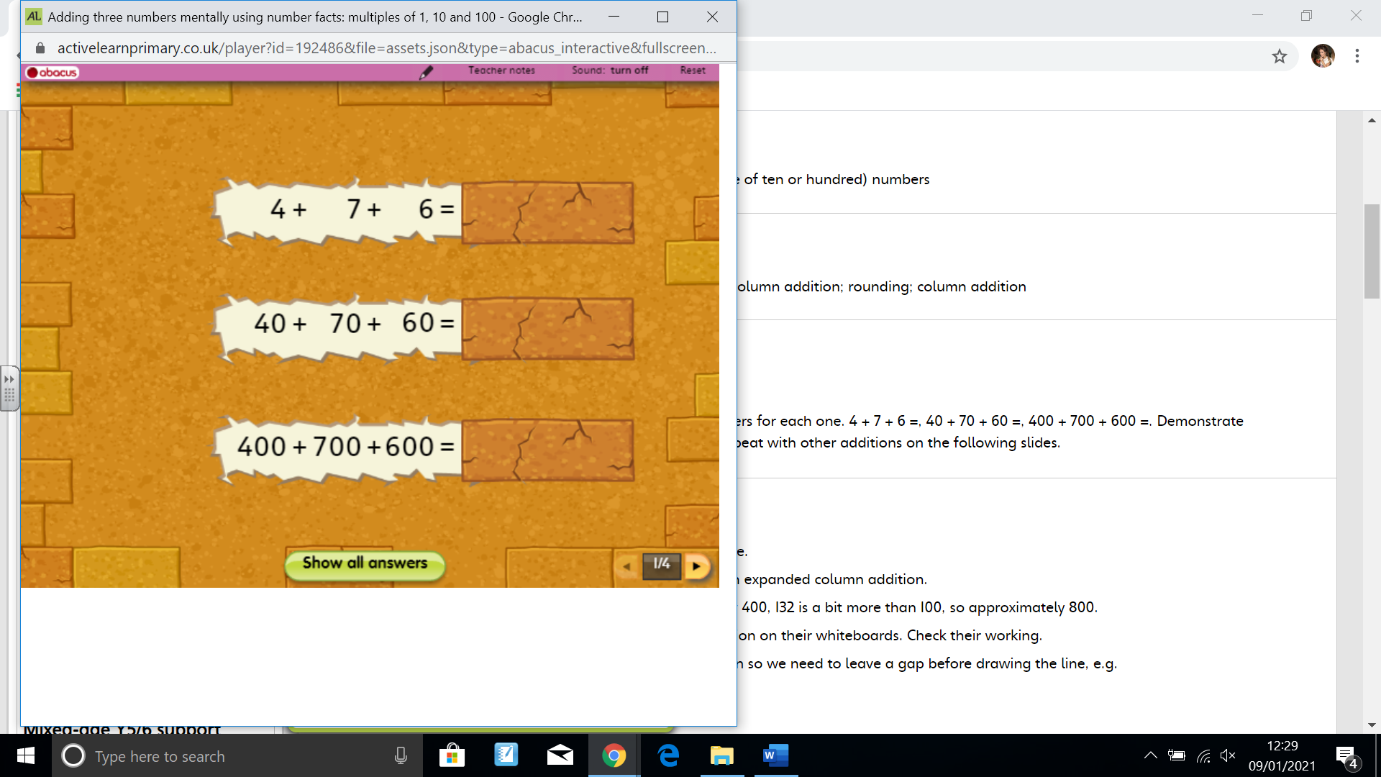
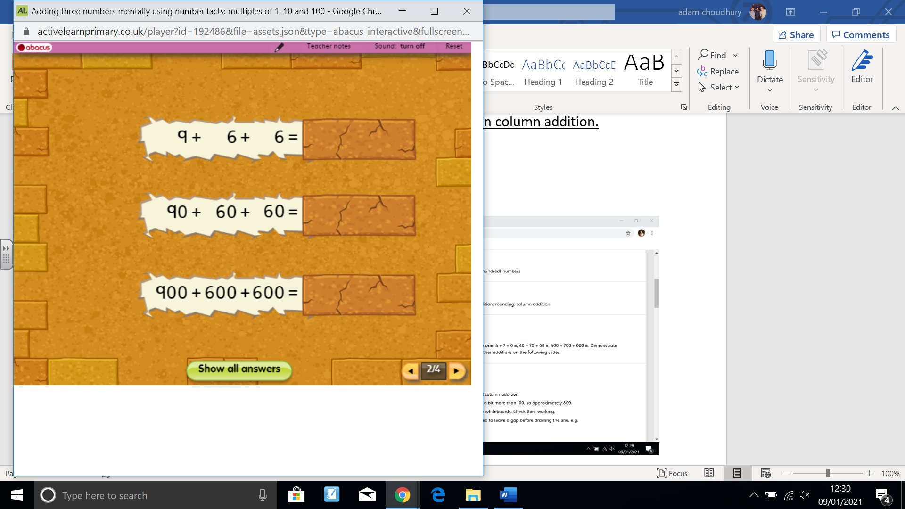
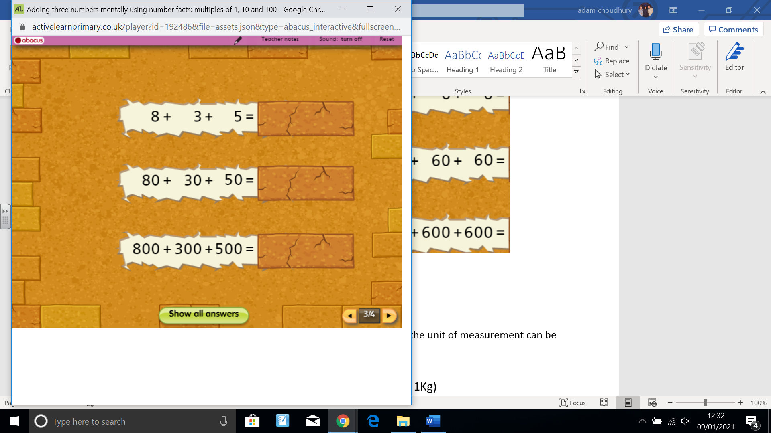

1) Are there any patterns in your answers? What are they?
2) Can you explain why?

Activity 1
Choose 3 bank cheques. Write them down as an expanded column method.
For example, £278

100s | 10s | 1s
200 | 70 | 8

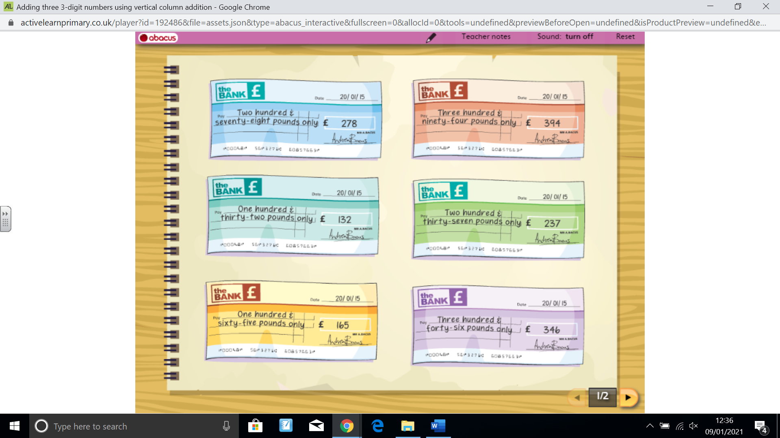

Activity 2

Can you estimate the total amount of these 3 cheques?

Example)
3 cheques of £289, £321, £469.

Round them to the nearest hundred

£289 is close to £300
£321 is close to £300
£469 is close to £500

Therefore, the estimated price of the 3 cheques is £500 + £300 + £300 = £1100

Now, work out the actual prcie of the cheques using the expanded column method
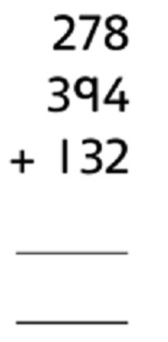

What is the anser?
Was this close to your estimate?

Activity 3)


