Monday 11th January 2021
LI: Newspaper Headlines
NEWSPAPERS
Examples of Newspaper Headlines

Headlines are found in different forms - in print newspapers, on radio and TV news and on Internet news sites. They are usually short and snappy! It should also summarise what the article will be about without giving too much away.
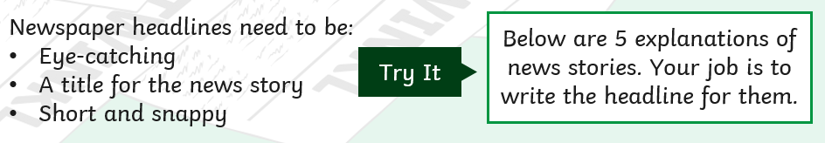
Can you try and make some headlines of your own?
- A boy finds a stash of gold Roman coins in the local park. Example, Local Boy Finds Ancient Treasure
- A girl from your local area is chosen for the Team GB Gymnastic team at the 2020 Olympics.
- A giraffe escapes from a zoo and makes it down the road into the supermarket car park.
- 500 dogs and their owners do a 5km run and raise thousands for charity.
- A bridge in a local town falls into the river causing chaos for the town.
Challenge Task
Choose one of your headlines and use your imagination to write a short article about it.
As well as a headline, please include the following:
SC




