Year 4 Spellings
Can you create sentences using your Year Four words?
Task 

Words of the week
Minute | Heart
Possible | Natural
Strange | Strength
Enough | Actual

Tricky - Create a simple sentence with each word
Trickier - Create a simple and compound sentence using each word
Trickiest - Create a simple, compound and complex sentence using each word

Don’t make it boring! 
Use adjectives and other interesting word choices. Use a wide range of punctuation.
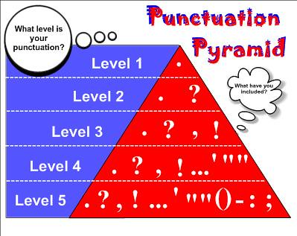
Extra Support
Write each word in a sentence into a sentence of your own
Beautiful | Find | After
Pass | Most | Told
Sugar | Hold | said

Finished? Use this game to practice your other key spellings
http://www.ictgames.com/littleBirdSpelling/

