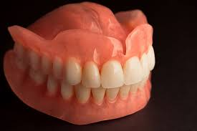
Teeth
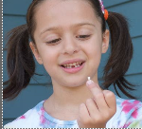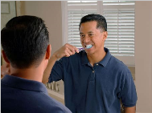
You bite into an apple and then try to start talking to your friend about yesterday's math homework. Suddenly something feels funny — one of your baby teeth has fallen out! It's been loose forever, and now there it is, right in your hand. And you have an empty space in your mouth big enough to poke a drinking straw through.
Before you put that tooth under your pillow, did you know that there is much more to that tooth than meets the eye? A single tooth has many different parts that make it work. And teeth play an important role in your daily life. They not only let you eat stuff like apples, they also help you talk. So let's talk teeth!

Click the following links to find out more!
https://www.youtube.com/watch?v=ZE-TtFhZlDw (Video about different types of teeth)
https://kidshealth.org/en/kids/teeth-movie.html (Video about how teeth work)
https://www.bbc.co.uk/teach/class-clips-video/teeth/zr8ygwx (How teeth help animals to eat)
Can you create a poster about teeth?
Things to include:
-The different types of teeth (labelled)
-How teeth help with digestion
-How to look after your teeth
-Any further fascinating information you can find out about teeth!


