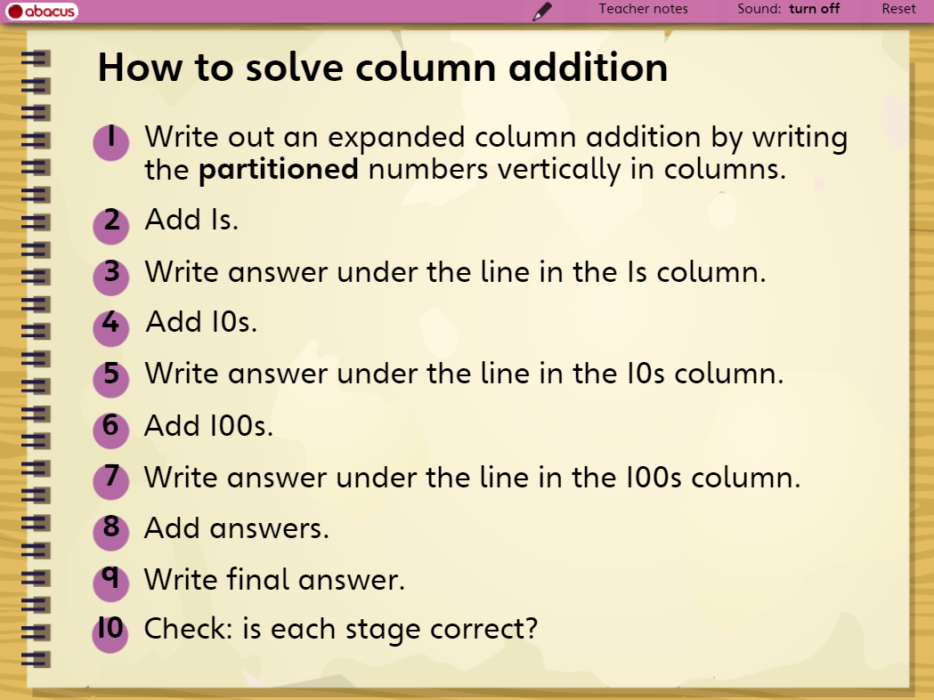
Task 1 - Complete calculations 1 and 2 that have been set out below.
Task 2 - Set out questions 3-7 in the same way and complete them.
Task 3 – Complete the challenge question.
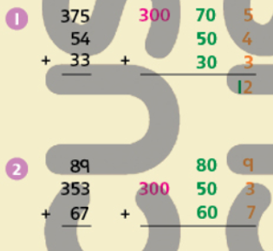

3. 75
53
+ 36

4. 248
+ 555

5. 95
288
+ 78

6. 257
+ 166

7. 517
166
+ 38

CHALLENGE - THINK QUESTION
For which of these additions would you use a written addition method and which would you do in your head?

352 + 104

352 + 267

352 + 199

