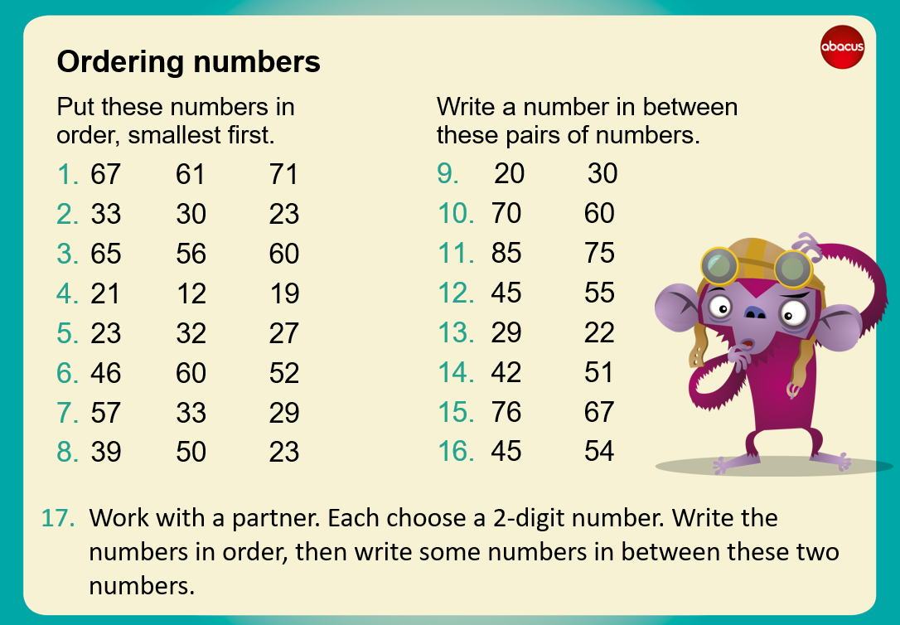
To complete … see examples below
- 61 67 71 (ordering numbers)

9. 20 23 30 (write a number that is between the pair given)

