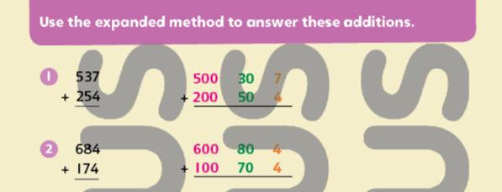

3. 473
7..
245 + 728

+ 261

4. 338
8.
496 + 373

+ 481

5. 467
9..
354 + 554

+ 319

73
53
+ 32
6. 578
10.
+ 319

THINK QUESTION
The answer to this addition is 583. Copy and complete.

. 300
+ 200 50 7
500 13

