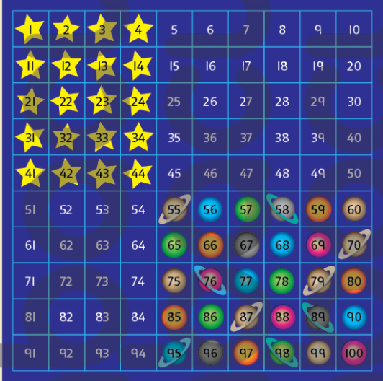
- 55(planet number) – 41(star number) = 14

55 – 41 =
First subtract the 10s 55 – (4 tens) = 15
Second subtract the 1s 15 – 1 = 14

2.
3.
4.
5.
6.
7.
8.

