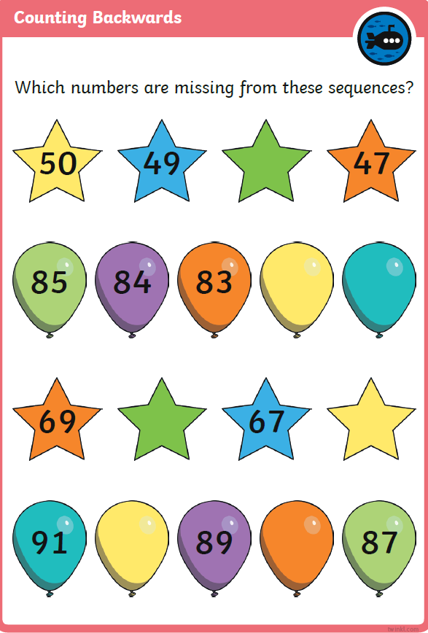
How can you use the other numbers to check your answer?

What comes before 49? _________
The number before 50 is 49. _________

The number before 90 is 89. _________

