Saint George and the Dragon
To explore features of legends and recall and retell the main events of the legend of ‘Saint George and the dragon’.

Task 1 - Learn about the features of legends by linking the images below with their descriptions.
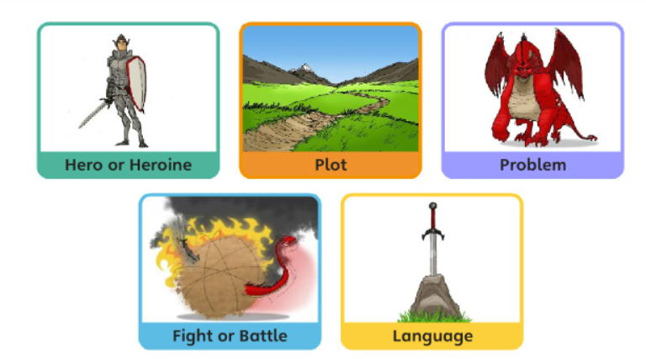
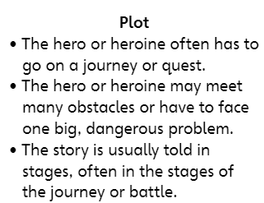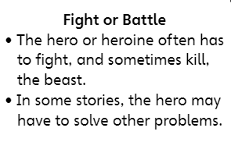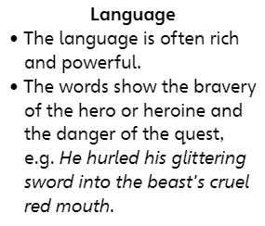
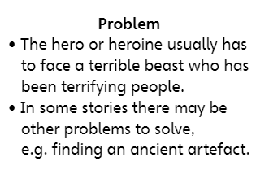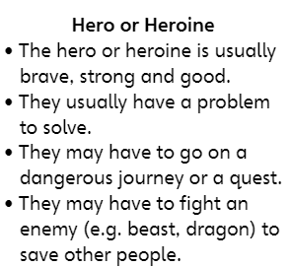

Task 2 - Read the legend of ‘Saint George and the dragon’ with an adult if necessary.
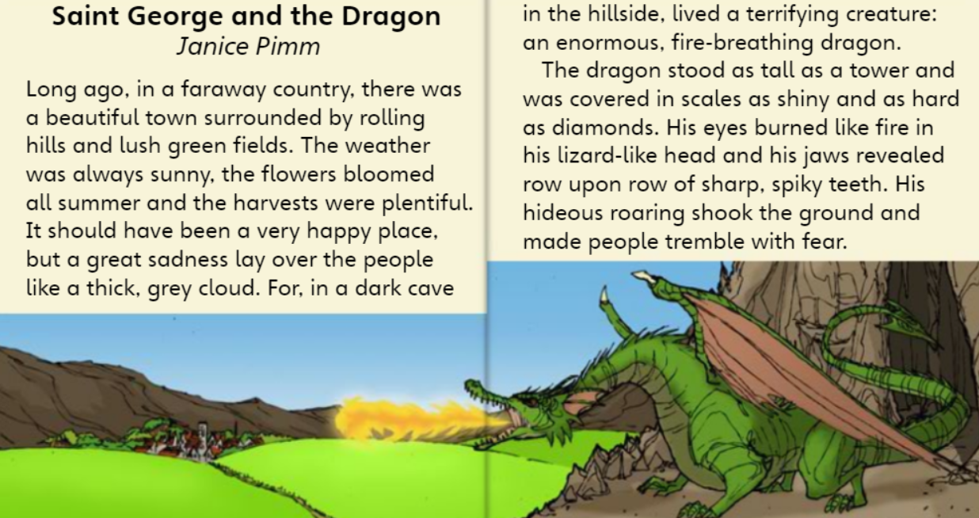

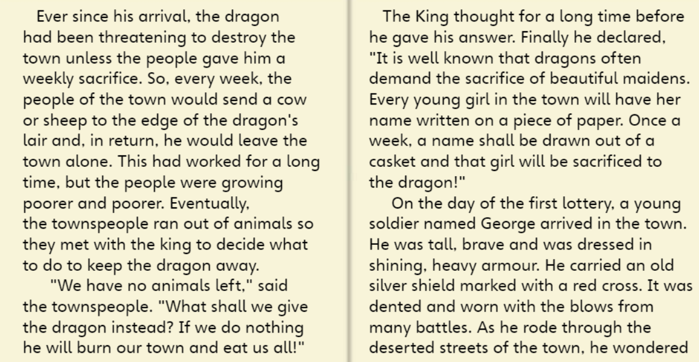
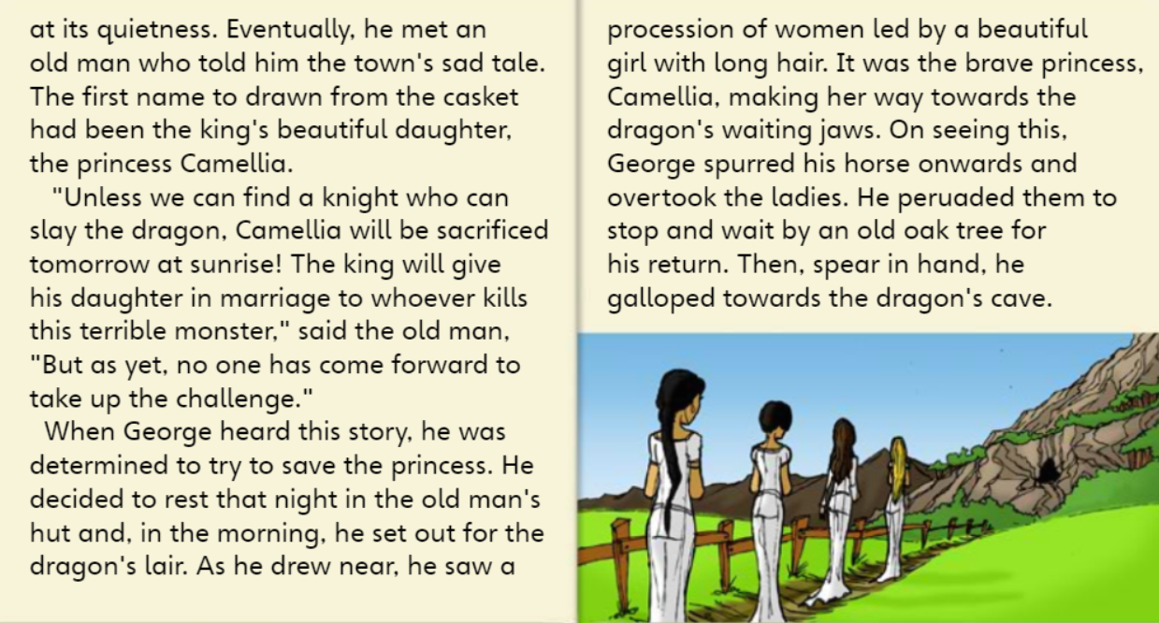
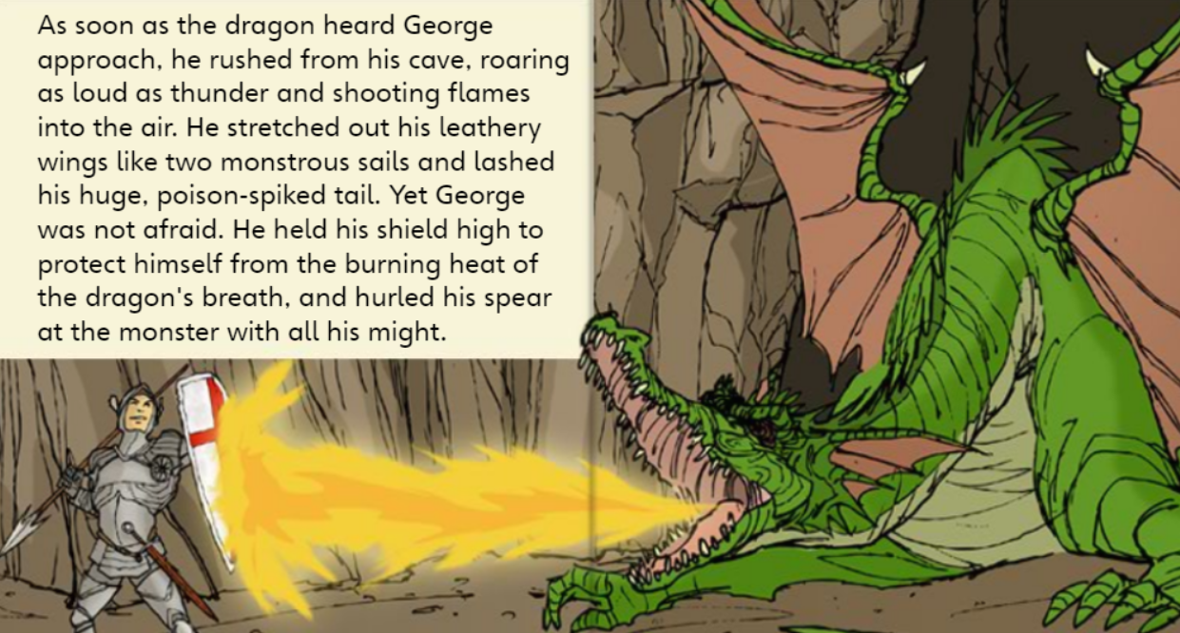
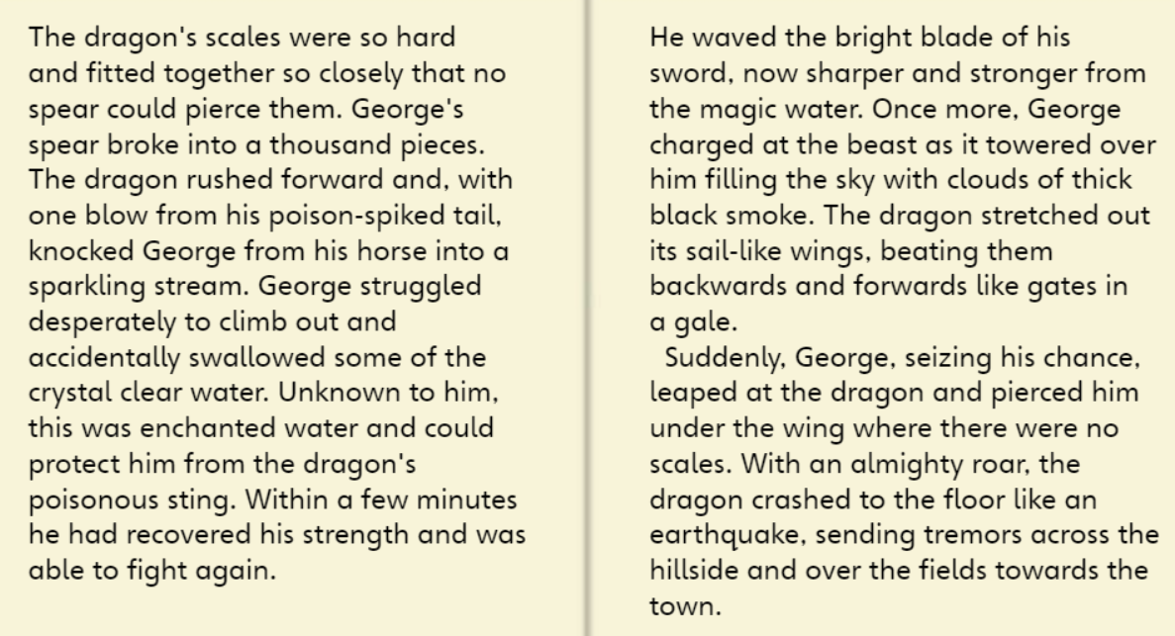
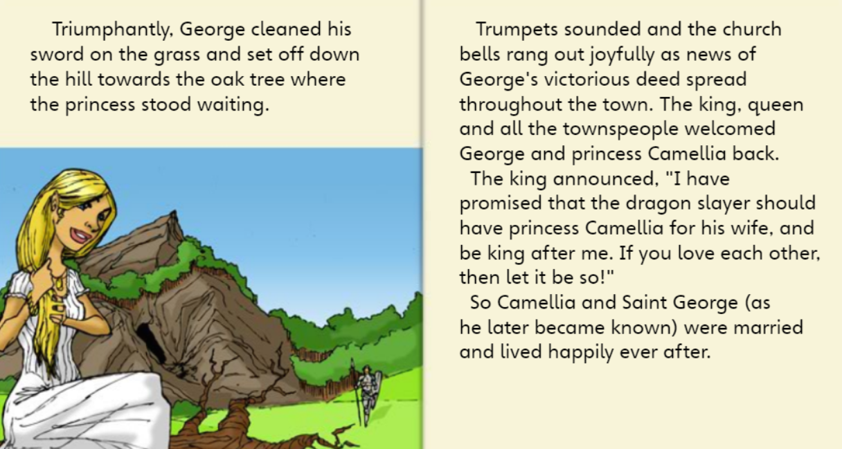

Task 3 – Answer the following questions using complete sentences with evidence from the text.

- When is this legend set?

_____________________________________________________________________________

- Are people happy?

_____________________________________________________________________________

- What is the beast like?

_____________________________________________________________________________

- Identify the good vs. evil theme as a feature of legends.

- What do we learn about George?

_____________________________________________________________________________

_____________________________________________________________________________

- Did anything surprise you?

_______________________________________________________________________________

- List any new vocabulary and use a dictionary to find the word’s meaning.

- Use one of your new words in a carefully punctuated sentence of your own.

_______________________________________________________________________________
________________________________________________________________________________

