Wednesday 6th January

The English word ‘dragon’ emerged in the 13th century from the latin word ‘draconem’, meaning ‘huge serpent’.

Look at / discuss the pictures of dragons below.



Tasks
- Generate vocabulary (nouns/adjectives) to describe dragons and write these around a dragon outline.
-Using some of these words, write a descriptive paragraph about dragons.

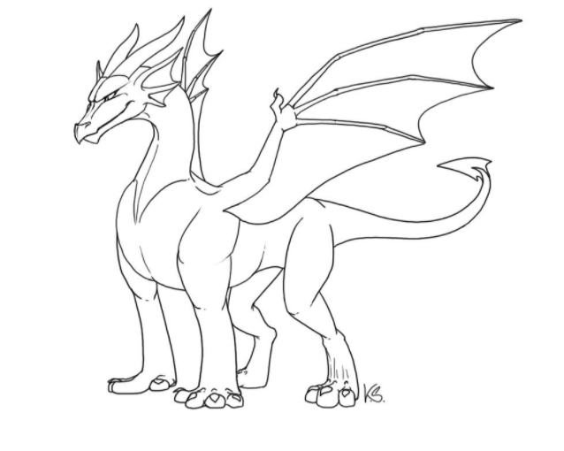

_

Dragons

______________________________________________________________________________________________________________________________________________________________________________________________________________________________________________________________________________________________________________________________________________________________________________________________________________________________________________________________________________________________________________________________________________________________________________________________
__________________________________________________________________________________

