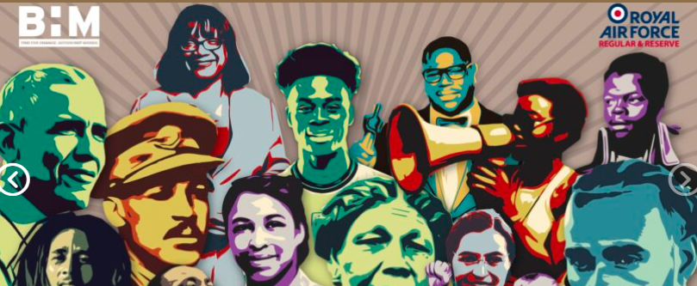
Year 5 homework – Black History Month
Return Date: 05/10/2022

Black History Month was created to focus attention on the contributions of African Americans to the United States.
It honours all Black people from all periods of U.S. history, from the enslaved people first brought over from Africa in the early 17th century to African Americans living in the United States today.

Your homework is to write a biography about one influential black person. This should be at least one page of A4. Below are some names to help you, or you could choose your own.

Maya Angelou, Kobe Bryant, Nelson Mandela, Serena Williams, Martin Luther King, Rosa Parks.

