Year 5 Homework
Return date: Wednesday 12th October

Maths
Can you use your maths knowledge to solve these problems on negative numbers?
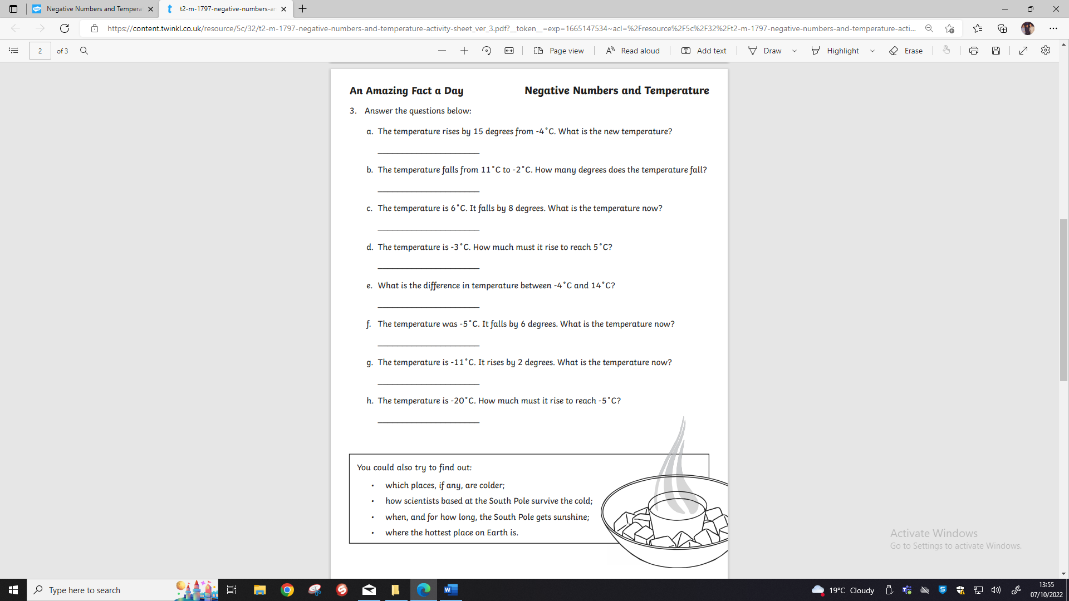
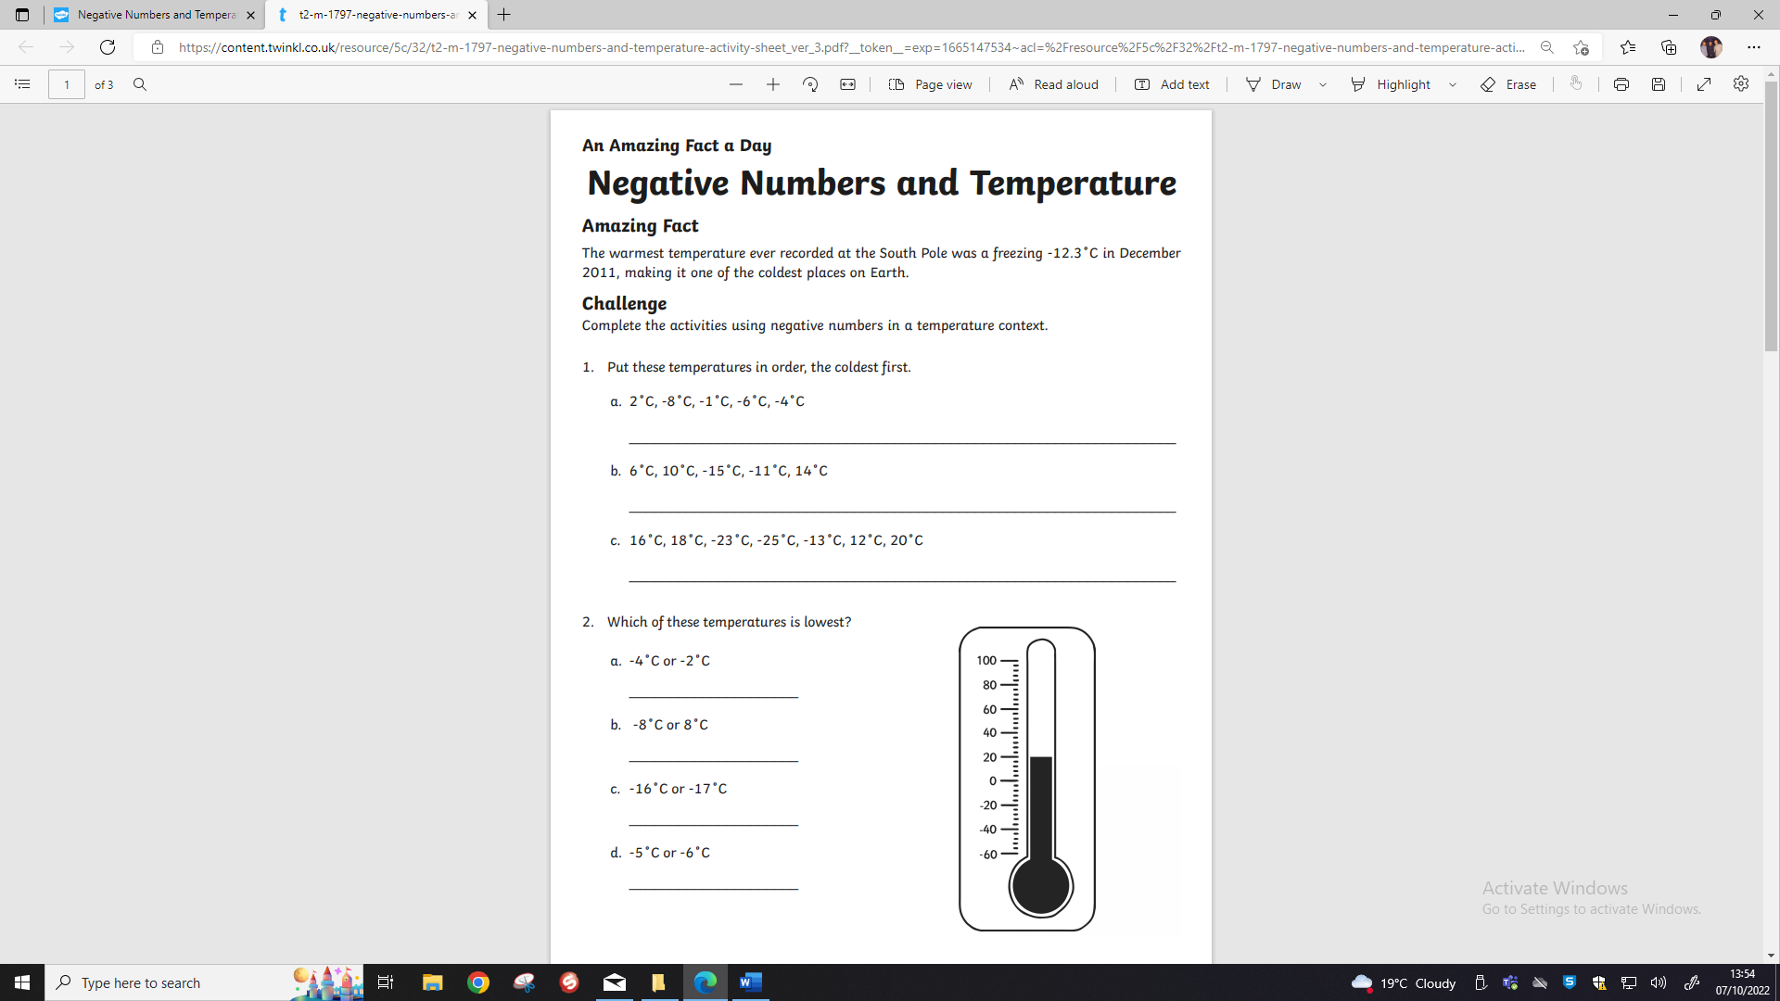



English

After our Assembly with Nathaniel Peat, many of you were inspired by his motivational words.

Your task for English this week is to have a think about what your ambitions are for the future, what do you want to achieve in your life? What is your dream job?

After taking some time to think deeply about this, you must create a poster all about how you will achieve your dream job.

Think about:
What can you do now to get started?
What skills do you need to learn at primary school to achieve your dream job?
How many years will it take for you to achieve this?
What will you need to study at secondary school?
Where do you see yourself in five years’ time? What will you be doing in your life at this point?
What steps do you need to take to get your dream job? (college / university / work experience).
What organisations are there online which may help you achieve this?
What is the most important thing you need to do to achieve your dreams?
Can you find any inspirational quotes to add to your poster?

