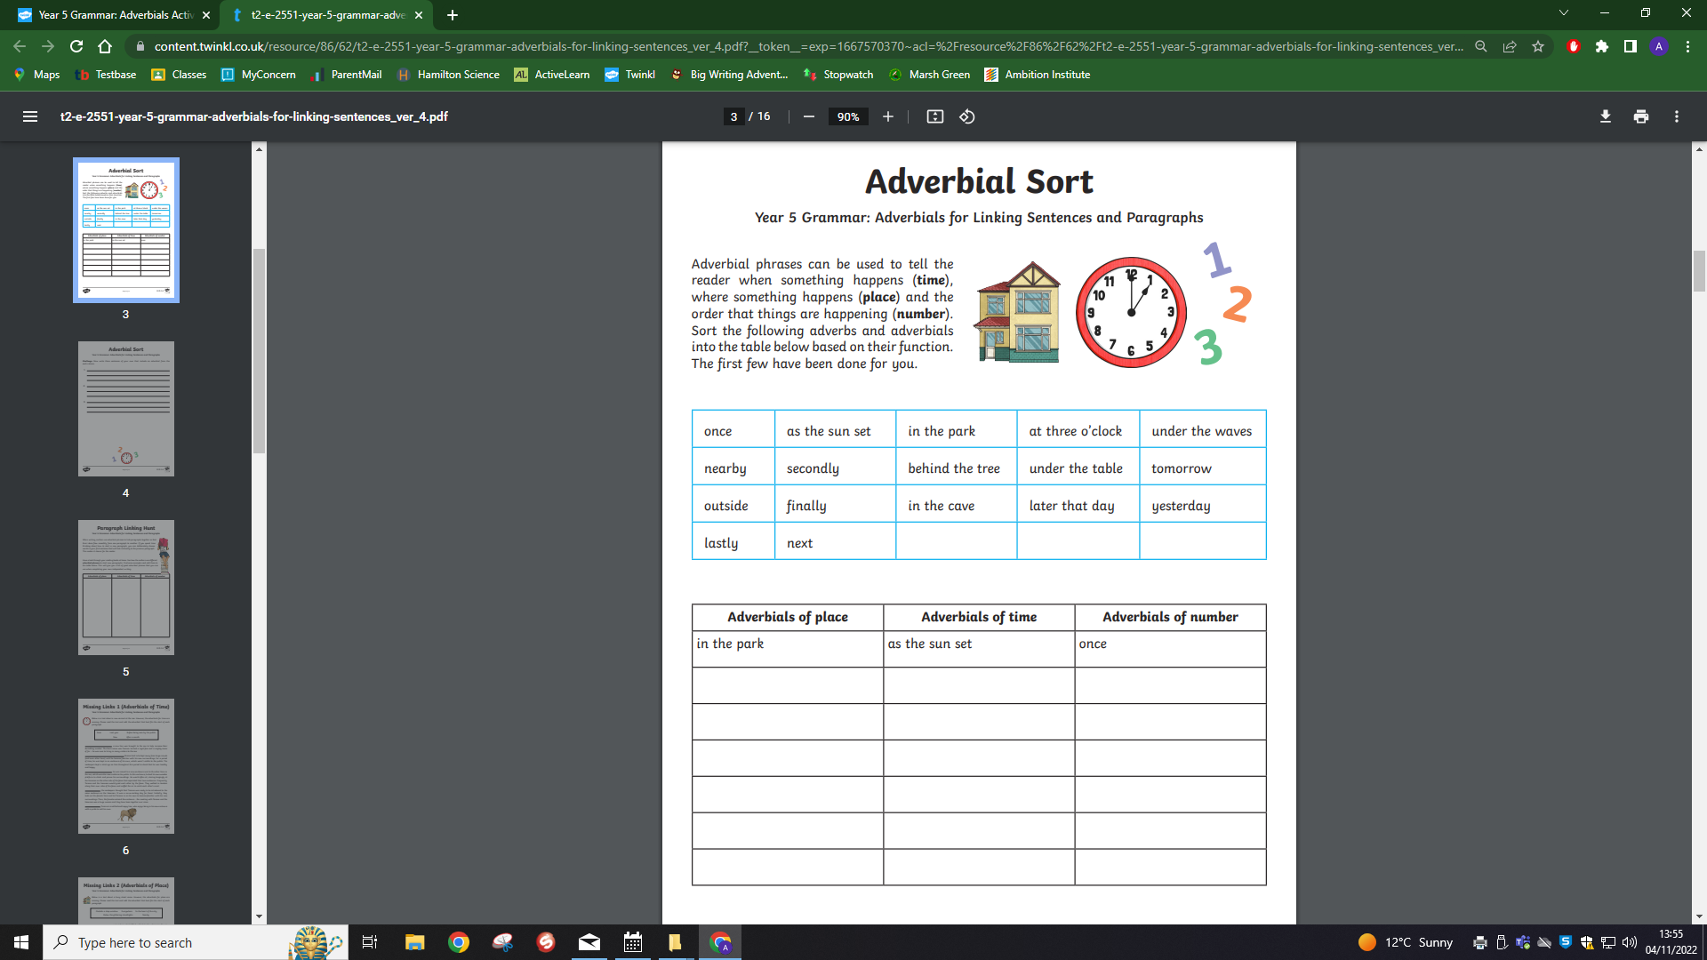
Can you now write 5 sentences of your own using Adverbials of time, place and number?

