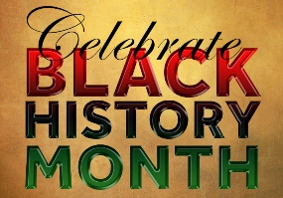
Black History Month Project (Phase 3 and 4)
 | Be a Writer / Detective / Artist
The children should choose a minimum of one task or more if they wish.  Children will be awarded house points upon completion of their projects.  To complete and return to your teacher by Friday 14th October 2022.  Have Fun! | Create a fact file about a famous black scientist, mathematician or inventor.  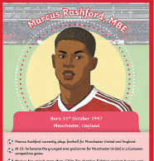  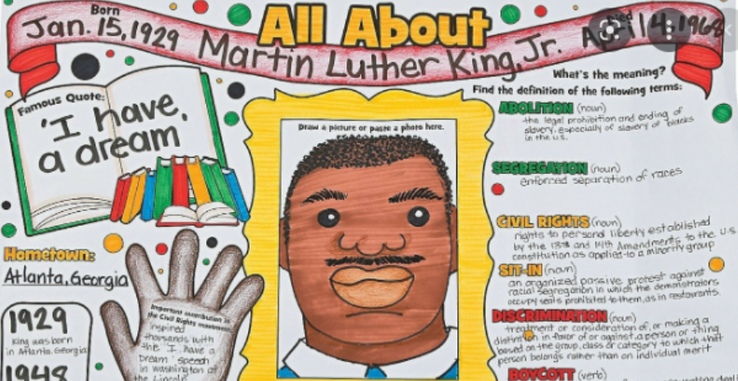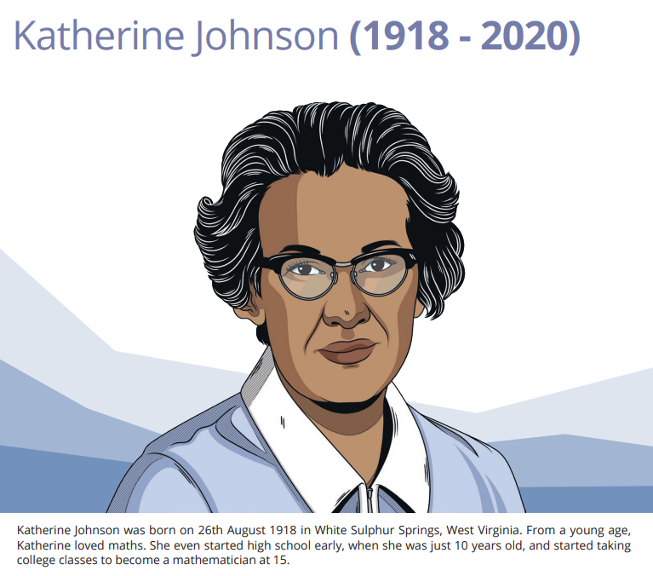  Create an acrostic poem about an inspirational black person.  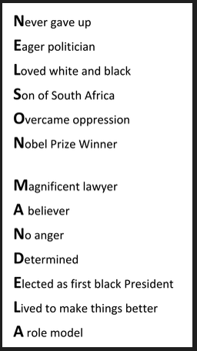 | 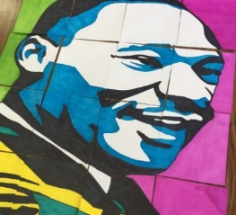  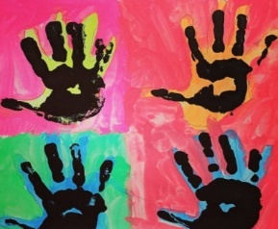  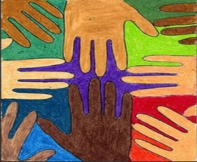  Design your own diversity image.  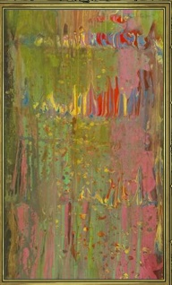  Paint in the style of a famous black artist  Frank Bowling experimented in creating abstract art  – Poured Painting.  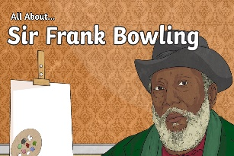  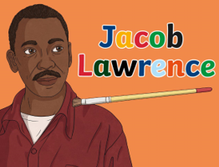  Jacob Lawrence explored ways to express and talk about our thoughts, feelings and emotions without having to use words.  Think carefully of a cause or story close to your heart, or maybe a life experience that has stayed with you.  Create a picture to show the thoughts, feelings and emotions that the story made you think of.
 | Talk and create task –  Talk to your adults at home about where you are from, draw a flag and include other interesting facts about your home country. | Watch this video clip about some modern as well as some historical black figures and carry out some additional research of your own.  https://youtube.com/watch?v=7SsprpsHSdU&feature=share  E.g. draw / paint / collage an image of the first black police officer - John Kent.

