‘Hello Yellow Day’, which we celebrated on the 10th of October 2022, raises awareness of the importance of young people’s mental health.
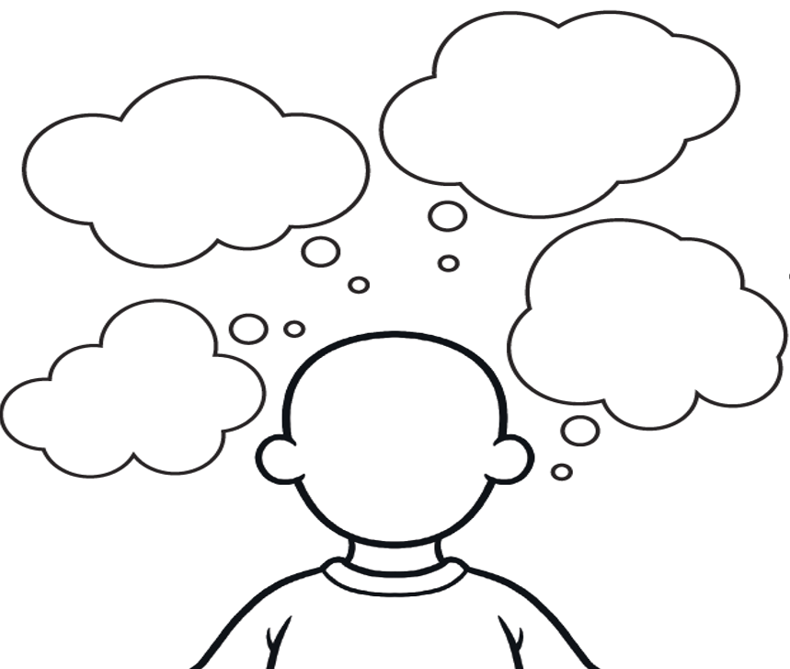
Although we are all unique, there are certain things that most people need to have good mental health. Write your ideas of what helps us all to have positive mental health in the thought bubbles.

