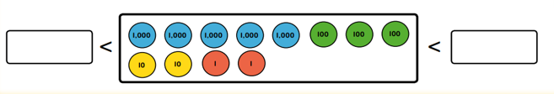
Maths Homework 14.10.22 Date Due: 19.10.22 Name __________________
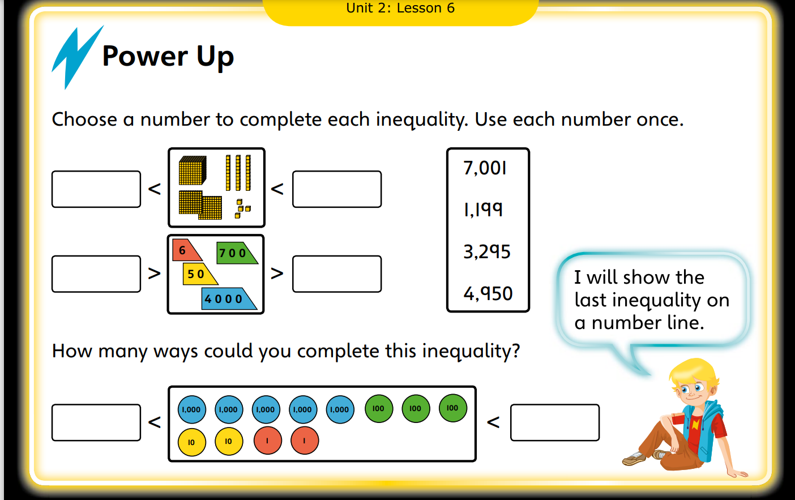

Counting forwards and backwards with positive and negative whole numbers.
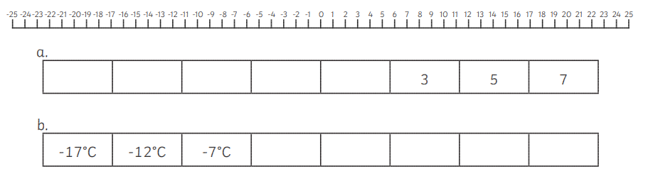
out the step in each sequence then use the number line to help you count forwards and backwards to complete them.

