Maths Homework 21.10.22 Date Due: 2.11.22
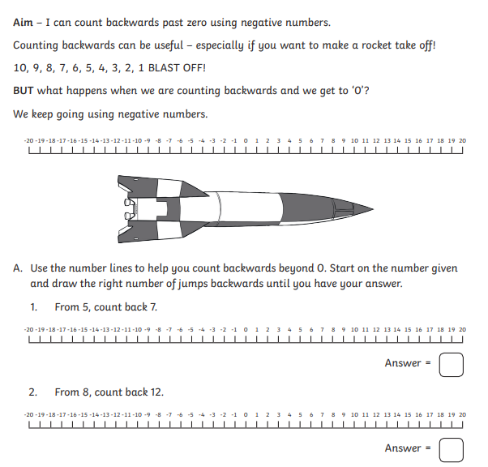
Name____________________
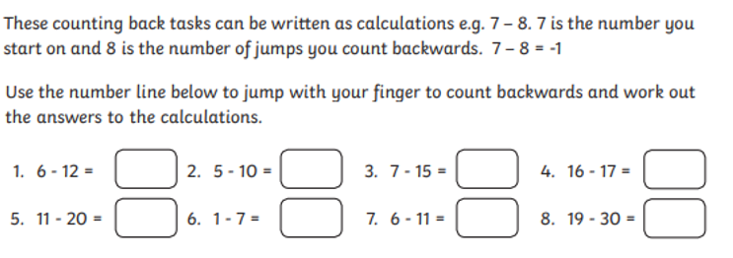
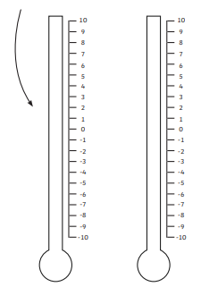
Being able to count back beyond 0 can help you to understand temperature changes. Imagine a thermometer is a number line but that it is on its side. Use the thermometer for drawing jumps on to help you answer the questions.

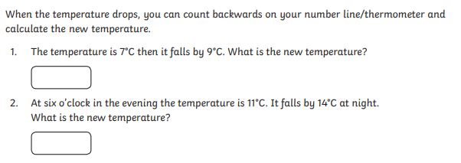
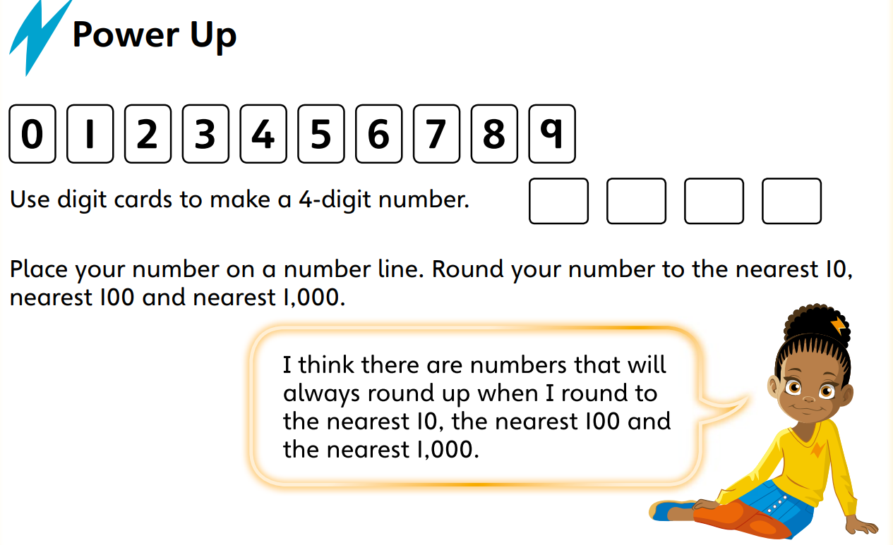
Practise Rounding Numbers

