Maths Homework (Group B) 21.10.22
Date Due:2.11.22 Name____________________
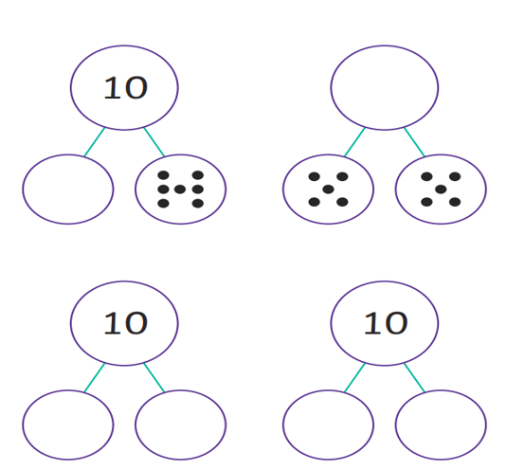
Complete the part-whole models to 10.

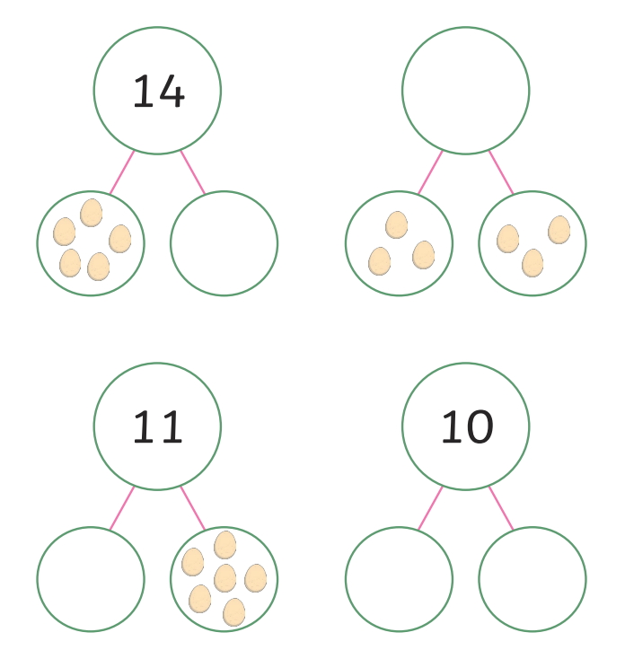

Complete the part-whole models to 20.

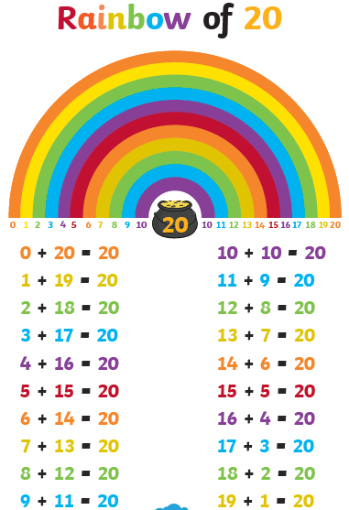
Learn your number bonds to 20
Use your knowledge of the number bonds to 20 to complete these tasks.
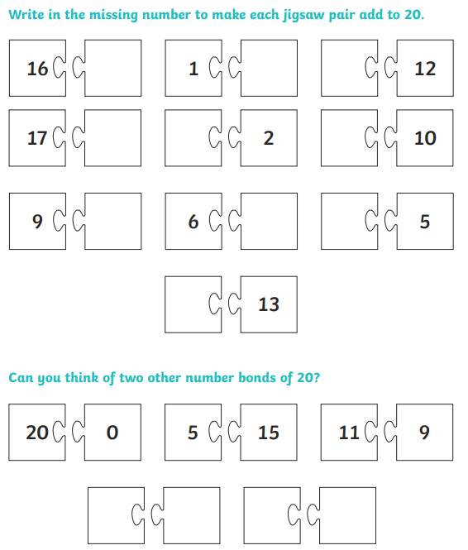
Use your knowledge of the number bonds to 20 to complete these tasks.


